Q1

**package** Day1;

**import** java.util.Scanner;

**public** **class** Question1 {

**public** **static** **void** main(String[] args) {

Scanner s=**new** Scanner(System.***in***);

**int** a;

System.***out***.println("Enter your marks");

a=s.nextInt();

String result= (a<=100 ? (a>40? " PASS ":" FAIL ") : "Invalid marks");

System.***out***.println(result);

// **TODO** Auto-generated method stub

}

}

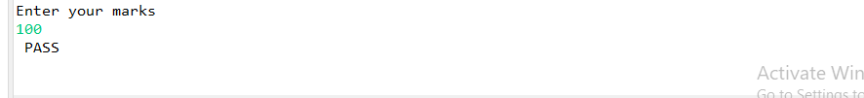

Q2

**package** Day1;

**import** java.util.Scanner;

**public** **class** Question2 {

**public** **static** **void** main(String[] args) {

Scanner sc=**new** Scanner(System.***in***);

System.***out***.println("Enter a number");

**int** number=sc.nextInt();

String result = (number >=0) ? "Positive" : "Negative";

System.***out***.println("your number is" + number +"and the number is" + result);

}

}

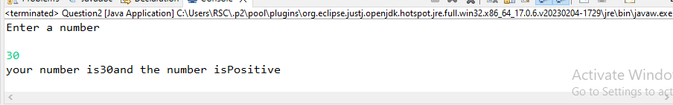

Q3

**package** Day1;

**import** java.util.*;

**public** **class** Question3 {

**public** **static** **void** main(String[] args) {

Scanner sc= **new** Scanner(System.***in***);

System.***out***.println("Enter your name");

String name = sc.nextLine();

System.***out***.println("Enter your age");

**int** age = sc.nextInt();

System.***out***.println("Enter your Salary");

**int** salary = sc.nextInt();

System.***out***.println("Input name is"+name);

System.***out***.println("Input age is "+age);

System.***out***.println("Input salary is"+salary);

}

}

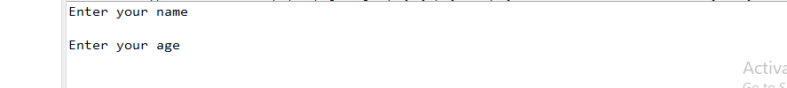

Q4

**package** pgdacmarch23;

**import** java.util.Scanner;

**public** **class** Question4 {

**public** **static** **void** main(String[] args) {

Scanner s=**new** Scanner(System.***in***);

System.***out***.println("Enter a number");

**int** a=s.nextInt();

System.***out***.println("Enter another number");

**int** b=s.nextInt();

**if**(a>b)

System.***out***.println("a is greater than b");

**else**

System.***out***.println("b is greater than a");

}

}

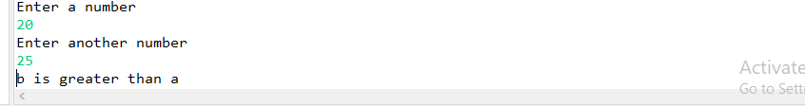

Q5

**package** pgdacmarch23;

**import** java.util.*;

**public** **class** Question5 {

**public** **static** **void** main(String[] args) {

Scanner sc =**new** Scanner(System.***in***);

System.***out***.println("enter product name");

String product =sc.nextLine();

System.***out***.println("enter product price");

**int** price =sc.nextInt();

**if**(price>2000) {

System.***out***.println(" you will get 10% discount");

}

**else** {

System.***out***.println(" you will get 7% discount");

}

**double** discount;

**if**(price>2000) {

discount=price*0.1;

}

**else** {

discount=price*0.07;

}

**double** discount_is = price - discount;

System.***out***.println("Product: " + product);

System.***out***.println("Price: " + price);

System.***out***.println("Discount: " + discount);

System.***out***.println("Discounted price: " + discount_is);

}

}

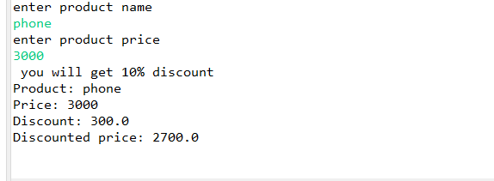

Q6

**package** Day1;

**import** java.util.*;

**public** **class** Question6 {

**public** **static** **void** main(String[] args) {

**int** x, y, t;

Scanner sb = **new** Scanner(System.***in***);

System.***out***.println("Enter the value of X and Y");

x = sb.nextInt();

y = sb.nextInt();

System.***out***.println("before swapping numbers: "+x +" "+ y);

t=x;

x=y;

y=t;

System.***out***.println("After swapping: "+x +" " + y);

System.***out***.println( );

}

}

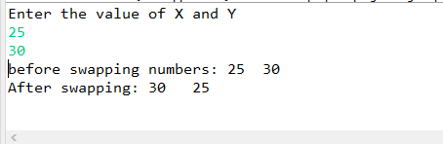

Q7

**package** Day1;

**import** java.util.*;

**public** **class** Question7 {

**public** **static** **void** main(String[] args) {

Scanner s = **new** Scanner(System.***in***);

**int** x,y;

System.***out***.println("enter first no");

x= s.nextInt();

System.***out***.println("enter second no");

y= s.nextInt();

System.***out***.println("Before swapping");

System.***out***.println("1st no=+x+\n+"+"2nd no="+y);

x=x+y;

y=x-y;

x=x-y;

System.***out***.println("After swapping");

System.***out***.println("1st no=+x+\n+"+"2nd no="+y);

}

}

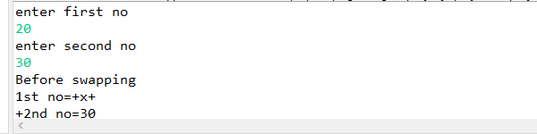

Q8

**package** Day1;

**import** java.util.*;

**public** **class** Question8 {

**public** **static** **void** main(String[] args) {

Scanner sc = **new** Scanner(System.***in***);

System.***out***.println("Enter a number");

**int** number = sc.nextInt();

**if**(number%2==0)

{

System.***out***.println(number + "Even number");

}

**else**

{

System.***out***.println(number + "Odd number");

}

}

}

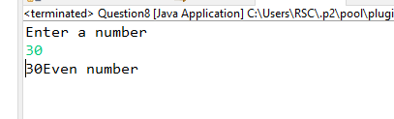

Q9

**package** Day1;

**import** java.util.*;

**public** **class** Question9 {

**public** **static** **void** main(String[] args) {

Scanner sc = **new** Scanner(System.***in***);

System.***out***.println("enter your mark");

**int** mark =sc.nextInt();

**if**(mark<100) {

**if**(mark<25) {

System.***out***.println("F");

}

**else** **if**(mark>=26&&mark<=45) {

System.***out***.println("E");

}

**else** **if**(mark>=46&&mark<=50) {

System.***out***.println("D");

}

**else** **if**(mark>=51&&mark<=60) {

System.***out***.println("C");

}

**else** **if**(mark>=61&&mark<=80) {

System.***out***.println("B");

}

**else** **if**(mark>=80) {

System.***out***.println("A");

}

**else** {

System.***out***.println("Invalid mark");

}

}

}

}

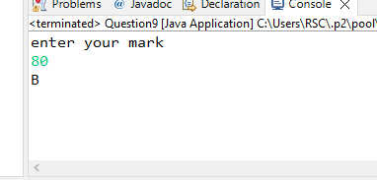

Q10

**package** Day1;

**import** java.util.*;

**public** **class** Question10 {

**public** **static** **void** main(String[] args) {

Scanner sc = **new** Scanner(System.***in***);

System.***out***.println("Enter three numbers");

**int** a=sc.nextInt();

**int** b=sc.nextInt();

**int** c=sc.nextInt();

**int** max=(a>b)?(a>c?a:c):(b>c?a:c);

System.***out***.println("max number is"+max);

}

}

